**PROBLEM STATEMENT:**

Identify the violation of one-way aisles in shops.

**AIM:**

To identify the violation of one-way aisles in shops.

**TOOL:**

PyCharm IDE

**TECHNICAL STACK:**

Python – OpenCV

**PROPOSAL FOR THE PROBLEM:**

With the help of the camera in the store, the number of persons entering the shop and leaving the shop can be detected. While shopping the motion of the people are detected to find whether they follow the one-way aisle. If anyone failed to follow the one-way aisle and start shopping in wrong direction, that person will be detected. This indicates that someone doesn’t follow one-way aisle. Finally, because of social distancing the number of persons allowed in a row will be restricted. If the limit of the person exceeds, then the beep sound will be generated.

**LOGIC:**

**motionDetect.py**

1. The necessary packages are imported.
2. The command line arguments are used. Its variables are used to parse command line arguments to a python directory.
3. Capture the video using webcam.
4. Otherwise, the video can be used. Here I have used the recorded video to capture the frame.
5. Get the frame width, height, and the Frames per second and print them.
6. Initialize the frame_count to 1.
7. Then, the background is subtracted using the function **createBackgroundSubtractorMOG2().**
8. Then, the frame is read.
9. In a while loop, get the frame of the video and the frame is converted to **grayscale using cvtColor().**
10. If there is no frame obtained then break.
11. The number of frames are counted.
12. The frame is resized using **imutils.resize().**
13. Initialize the variables such as people_count, totalUp and totaldown to zero.
14. The direction of the movement of the people is determined with the function **calcOpticalFlowPyrLK().**
15. Then the difference between the frames are calculated.
16. Thresh is applied using the function called threshold().
17. Then, find the contours.
18. Inside for loop, the rectangle is drawn using **boundingRect()** to detect the motion of the people.
19. Then the rectangle is defined.
20. The variables such as people_count, totalUp and totalDown is incremented based on the entry and exit of the people which is determined by the direction of the people.
21. Then, the counts of the variables are displayed in the frame.
22. And also the status of the motion of the people is displayed.
23. Then, if the people count in a row exceeds the limit, the beep sound is produced and also if they walk in the wrong direction, a beep will be produced.
24. Finally the frames are displayed and the total number of frames are incremented.

**SAMPLE OUTPUT:**

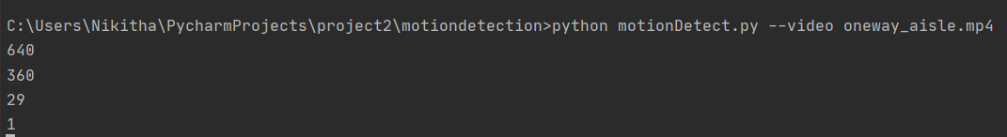

Figure 1 ‘Displaying the Frame width, height, frames per second and the frame count

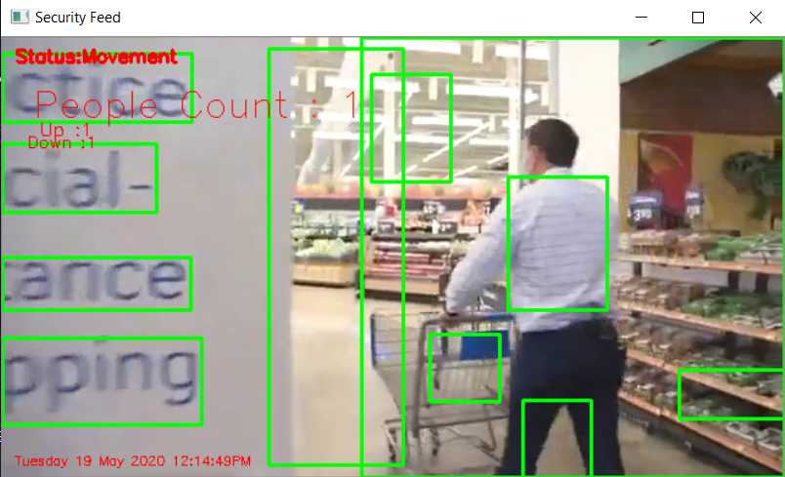

Figure 2 ‘Detecting a person by drawing a contour’

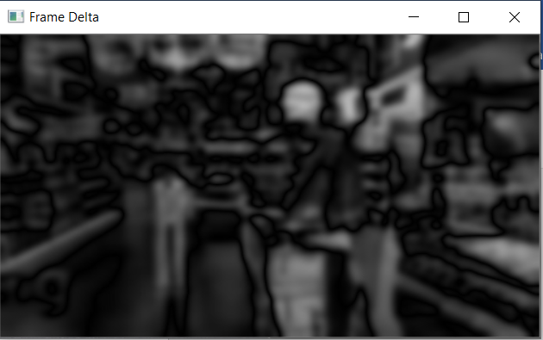

Figure 3 ‘Frame delta indicating the motion is taking place’

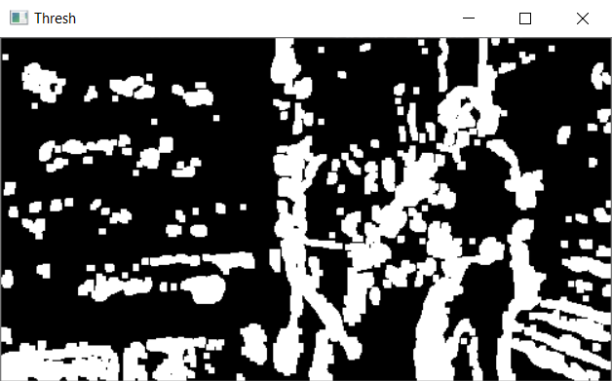

Figure 4 ‘Thresholding the frame delta image to segment the foreground from the background’

**MERITS:**

* Python OpenCV reduces the lines of code by providing the inbuilt functions.
* It offers concise and readable code.
* Python has great data handling capacity.